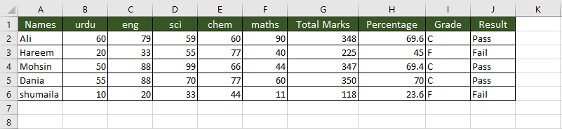

|  |  |
| --- | --- |
| Sum Formula | =SUM(B2:F2) |
| IF Formula | =IF(H2<50,"F",IF(H2>60,"C",IF(H2>70,"A"))) |
| Percentage Formula | =G2*100/500 |
|  |  |